**FPS Inventory**

**USER GUIDE**

**Printed: April 17, 2020**

**Table of Contents**

**Add an Employee 1**

**Add a Product 3**

**Add a Store Location 5**

**Lookup all products for a Category 7**

**Lookup Inventory for a specific Store 8**

**Lookup transactions for a store in a date range 10**

**Place Order with Supplier 12**

**Add an Employee**

1. Login to system (must be Admin to access employee files)
2. Select “Employee” Tab

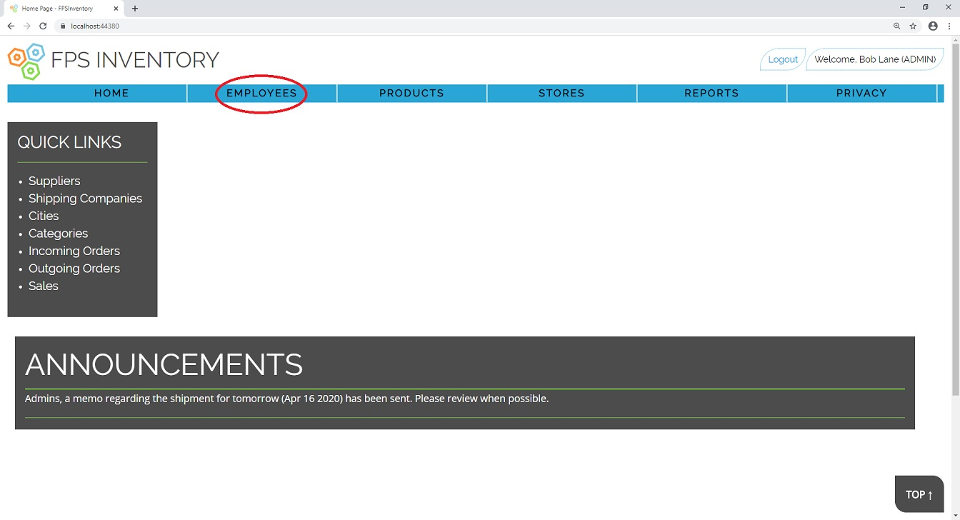

1. Select “Create New” above the table of employees on file

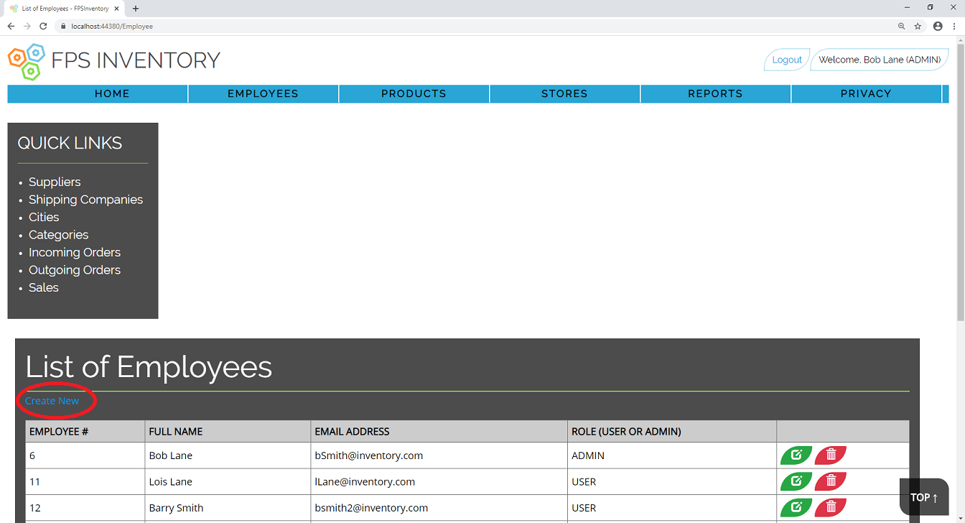

1. Enter Employee information:
2. Name cannot be more than 30 characters
3. Email address must be valid and unique, cannot have 2 employees with same email.
4. Gender must be either M, F, or X (Single character only)
5. Role must be either User or Admin (case ignored but must be spelt correctly).
6. Click “Create”

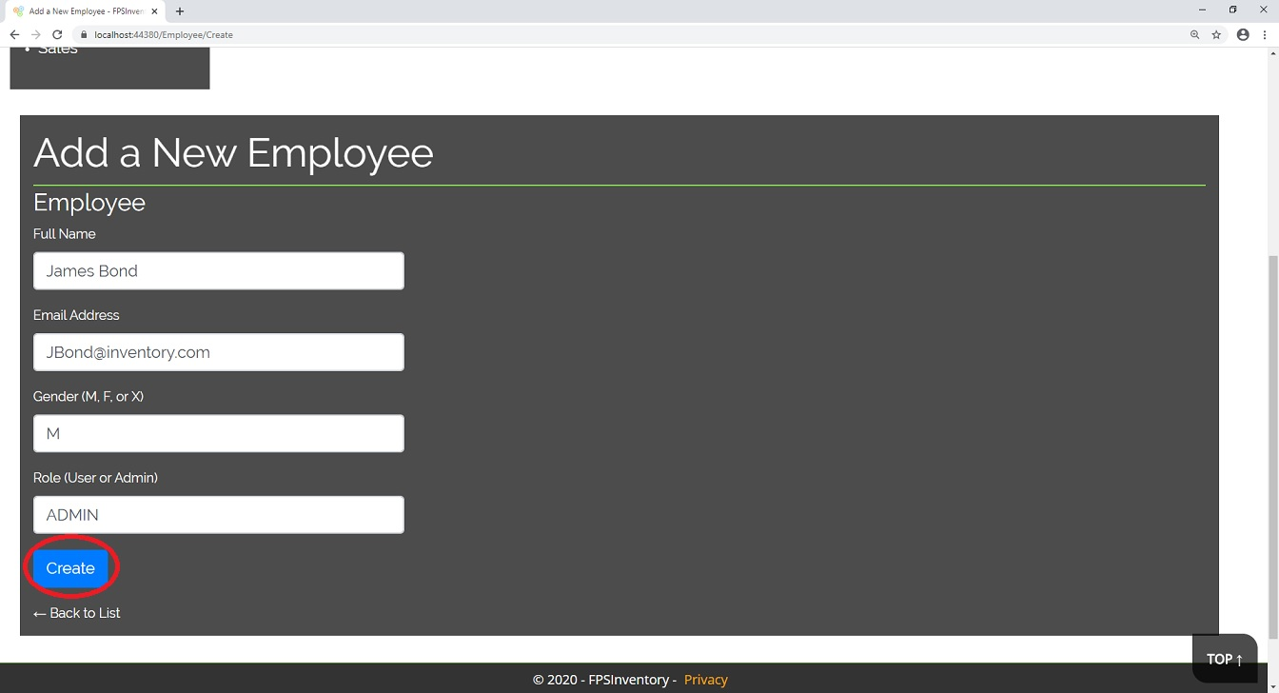

1. Verify employee has been added to list of employees.

**Add a Product**

1. Login into system (Must be Admin to Add products to the system)
2. Click on “Products” tab

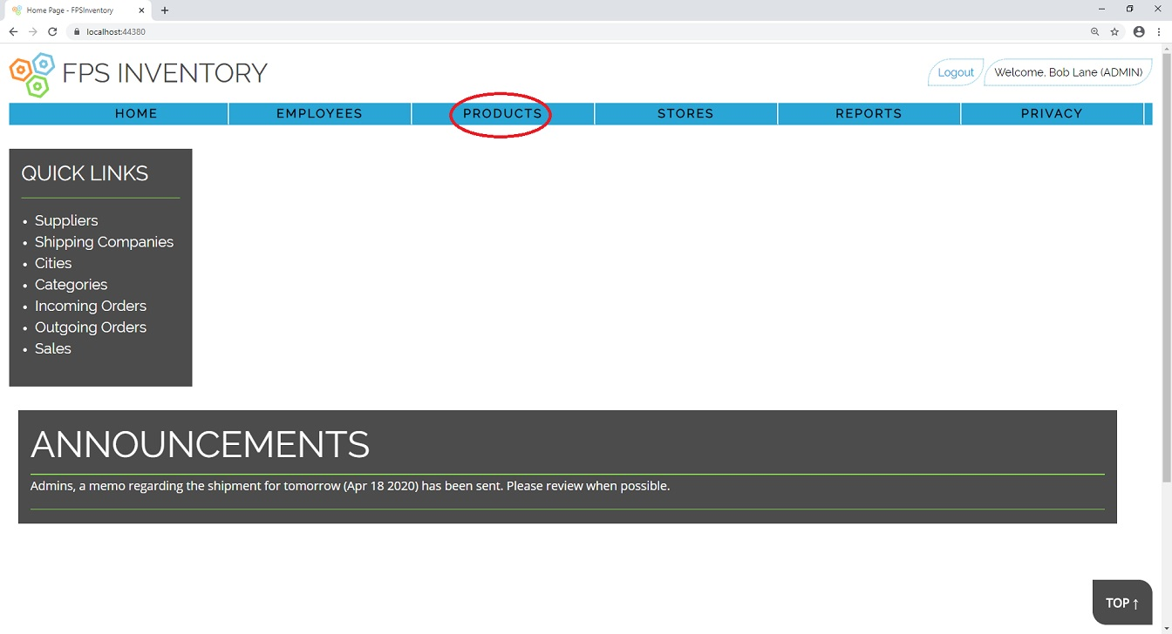

1. Click on “Create New”

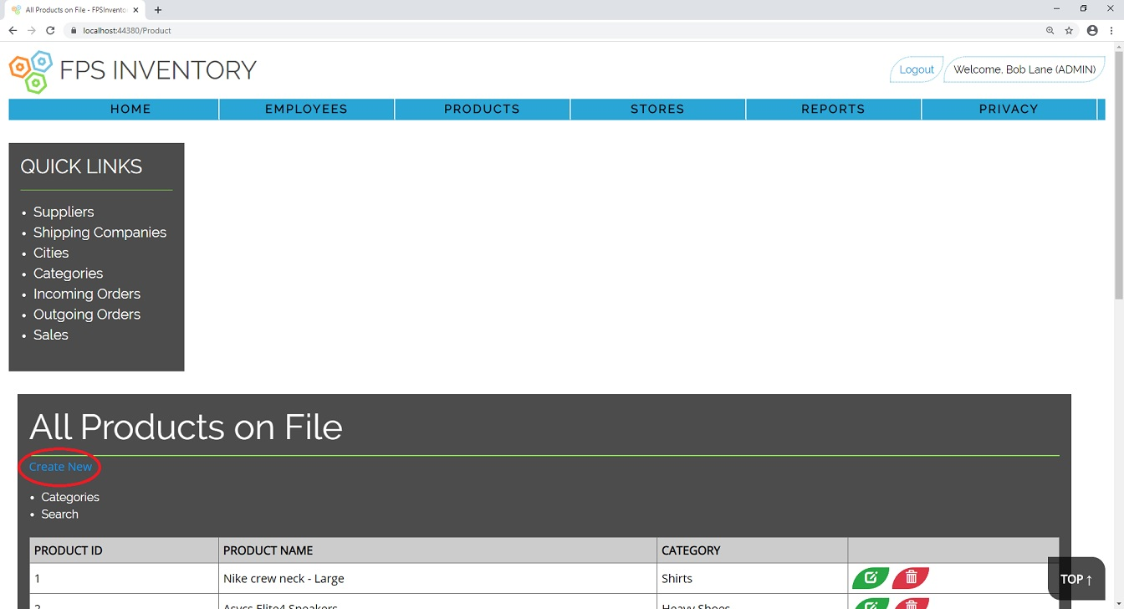

1. Fill in a description for the product and select a category to list it under.
2. Click on “Create”

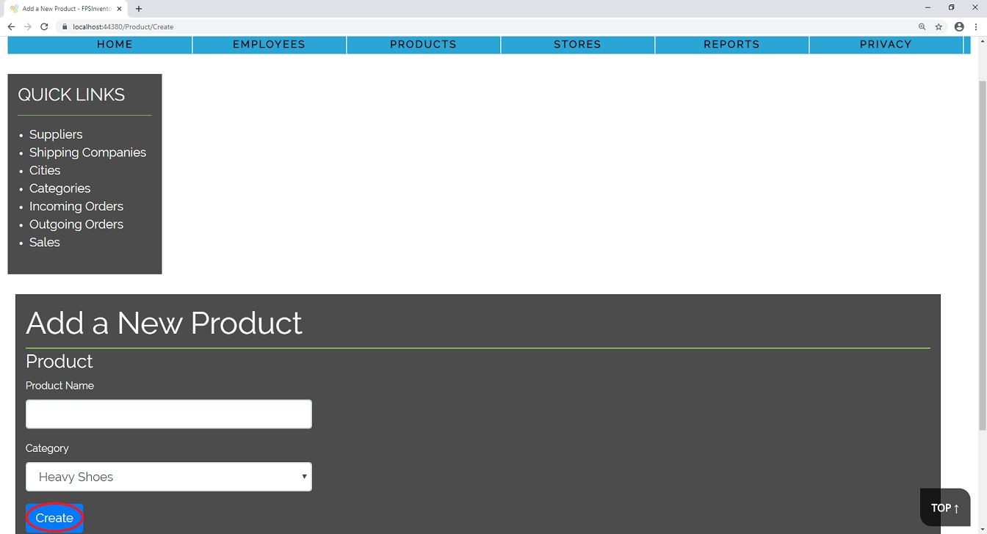

1. Verify that the product is added to the list of products.

**Add a New Store Location**

1. Login into the system (Must be Admin to Add New Store)
2. Click on “Stores” tab

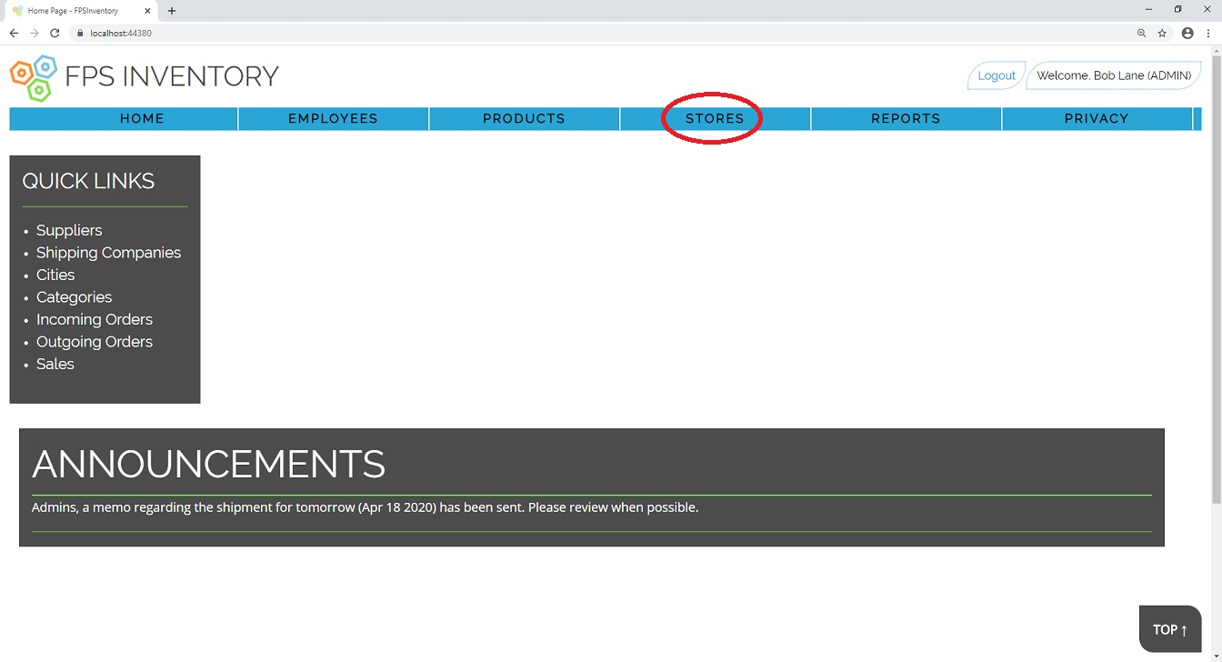

1. Click on “Create New” above the list of stores

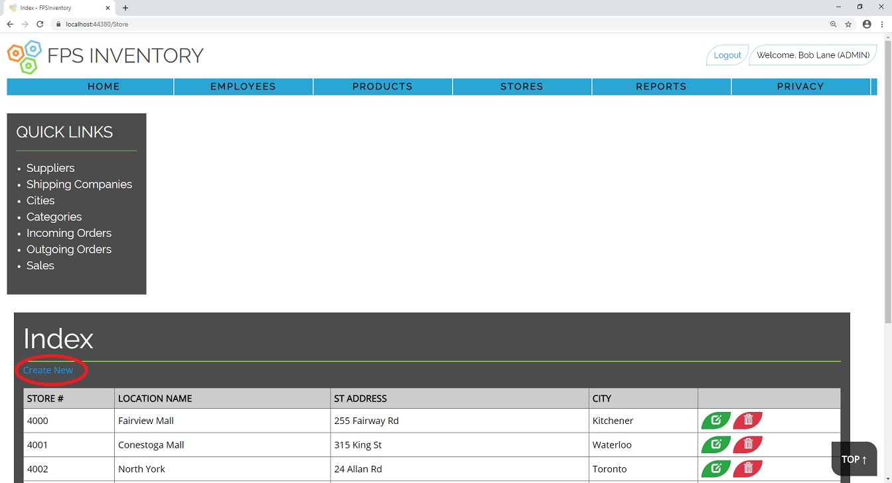

1. Fill in the Location Name, St Address, and select the city from the dropdown.

NOTE: Creation will error if you try to call 2 locations the same name or have 2 locations with the same St. Address and City.

1. Click “Create”

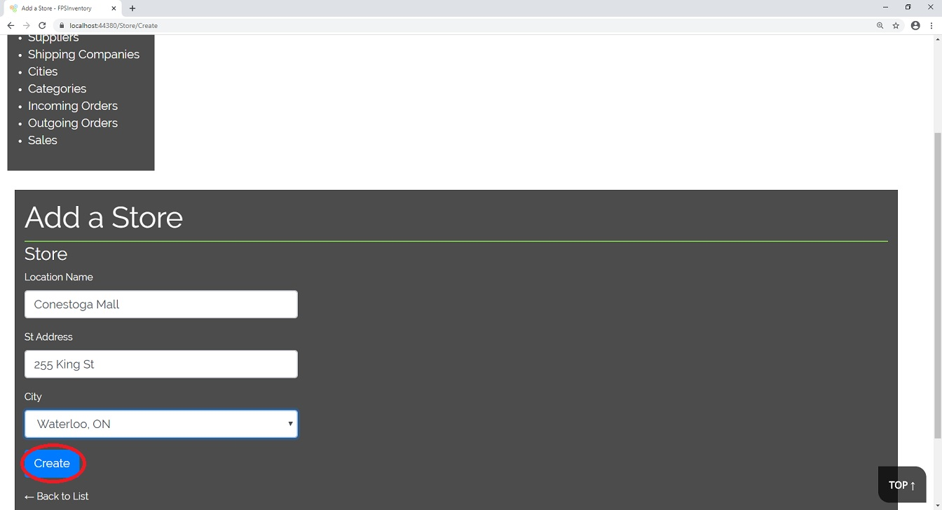

1. Verify that the new Store is listed with the other stores.

**Lookup all products for a Category**

1. Login into the system (User or Admin allowed)
2. Click on “Products” tab.
3. Click on “Categories” link

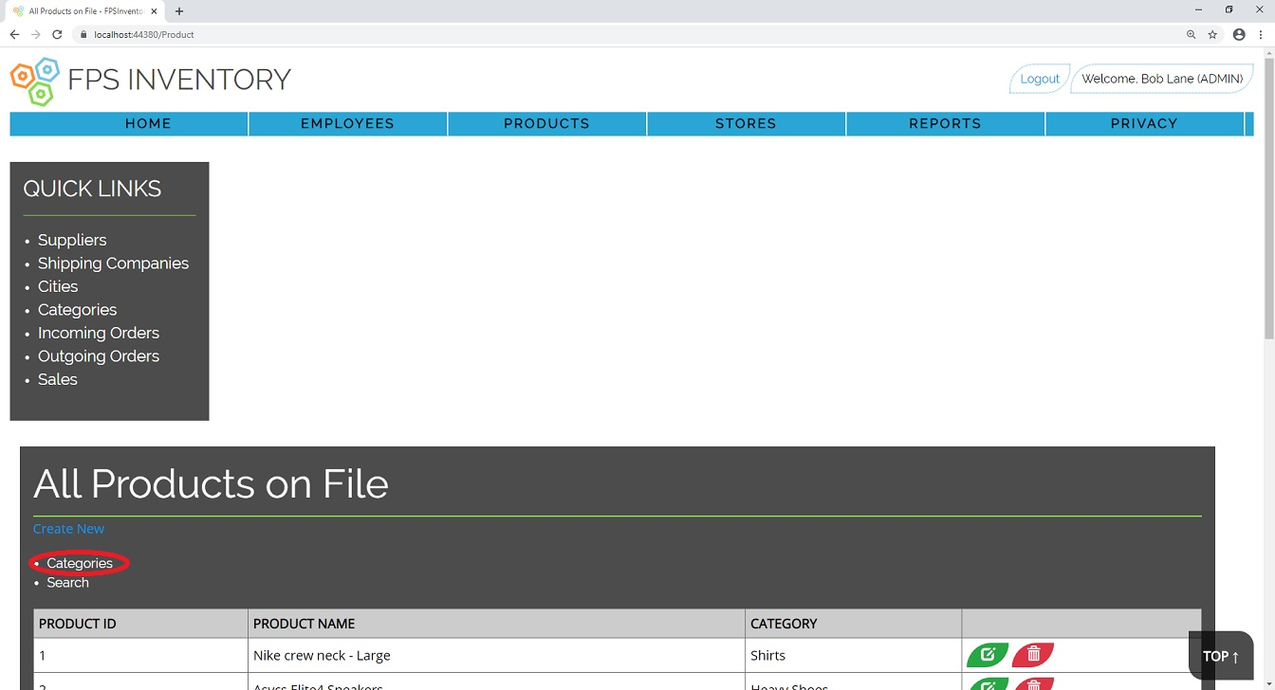

1. Select your desired Category by click on the Category name from the list.

**Lookup Inventory for a specific Store**

1. Login into system (User or Admin allowed)
2. Click on “Reports” tab

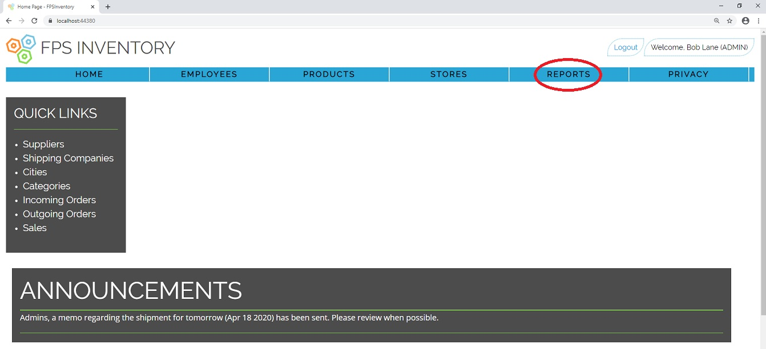

1. Click on “View Store Inventory”

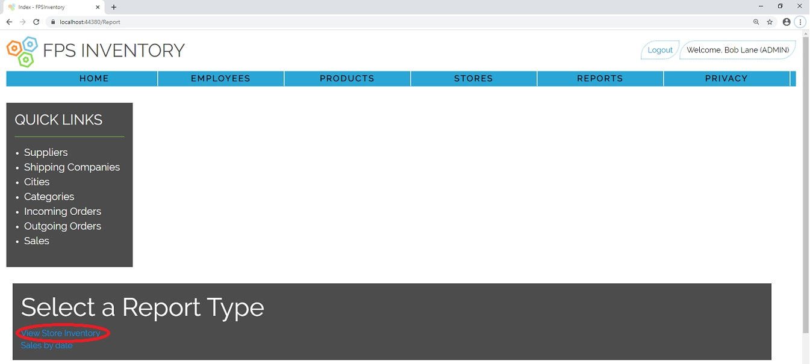

1. Click on “View Inventory” for the location you wish to review

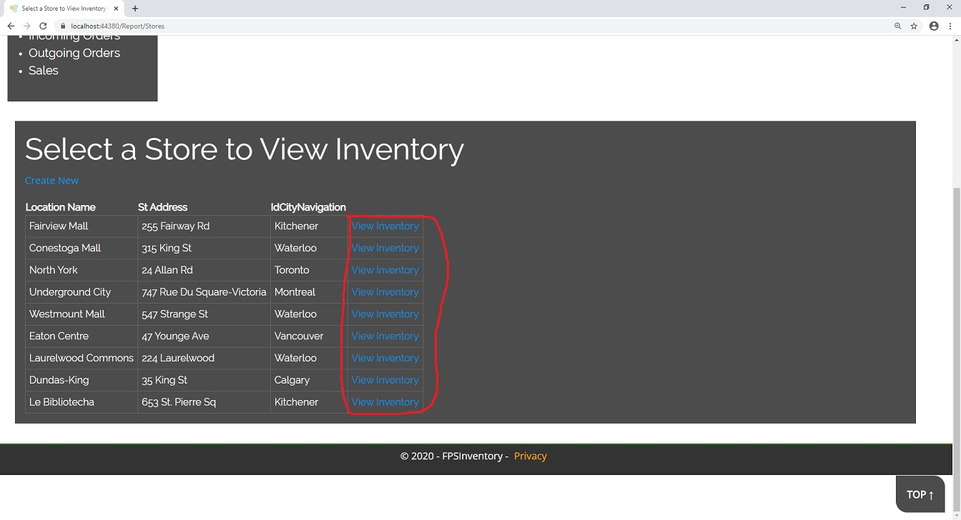

1. A report of the full inventory of that location will be displayed in a table format.

**Lookup transactions for a store in a date range**

1. Log into system (User or Admin allowed)
2. Click on the “Reports” tab



1. Click on “Sales By Date” link

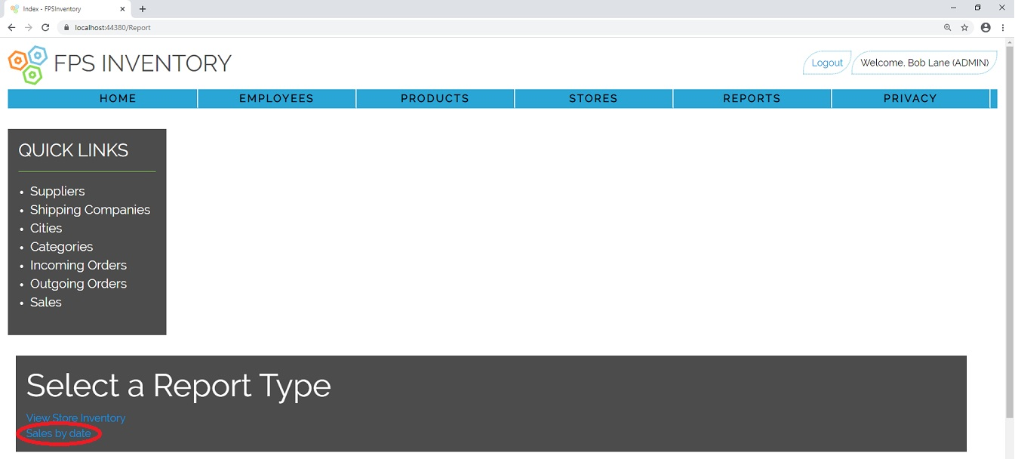

1. Select a store from the dropdown list and enter your desired Date Range (left box start date, right box end date).
2. Click “Search”

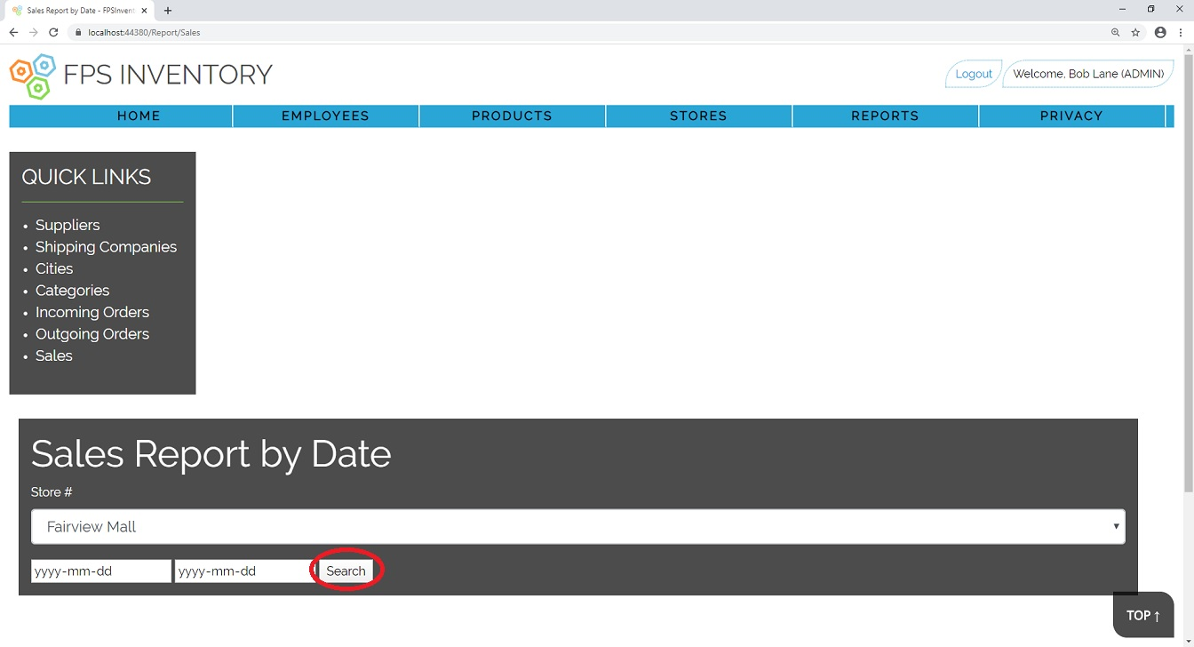

1. A report of all the transactions for that location within that date range will be displayed in a table format.

**Place Order with Supplier**

1. Log into the system (User or Admin allowed)
2. Click on “Incoming Orders” link under “Quick links” box

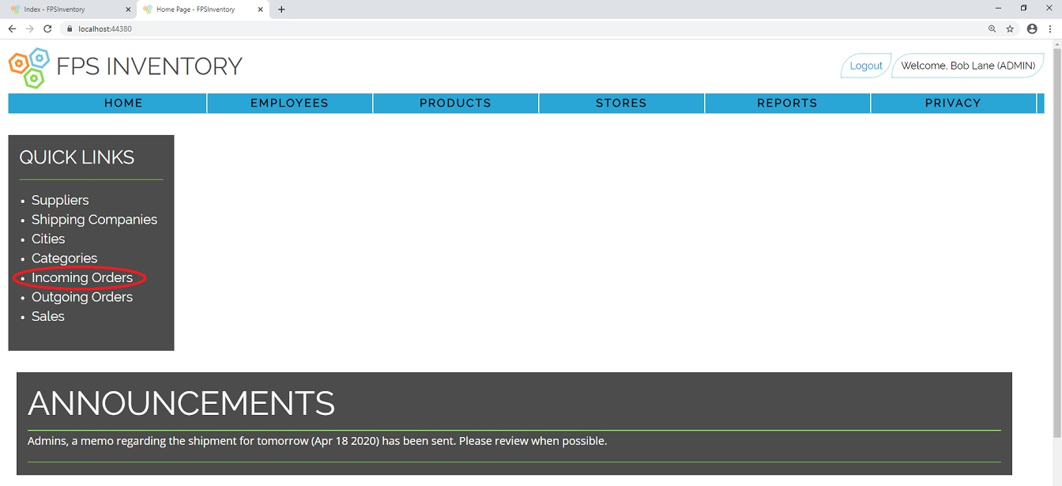

1. Click “Create New” link above the list of Orders

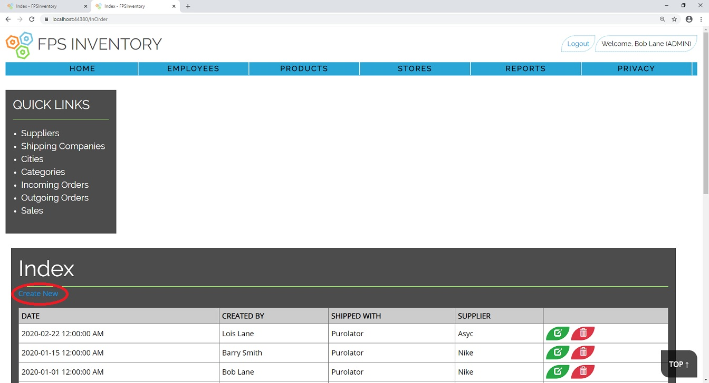

1. Fill in order form with desired shipping company, supplier, the employee placing/authorizing the order, and the date of the order.

NOTE: Order Date cannot be in the future, must be current date or sooner.

1. Click “Create”

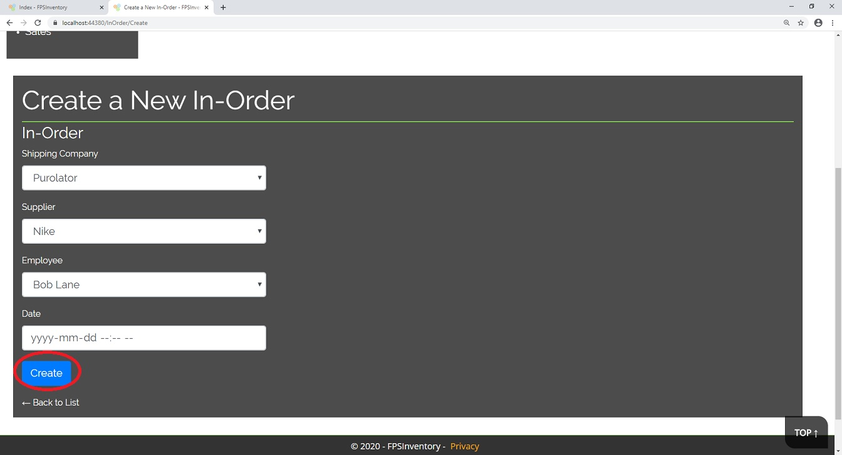

1. With the order created you may now add items to the order.
2. Click “Add Product to Order”

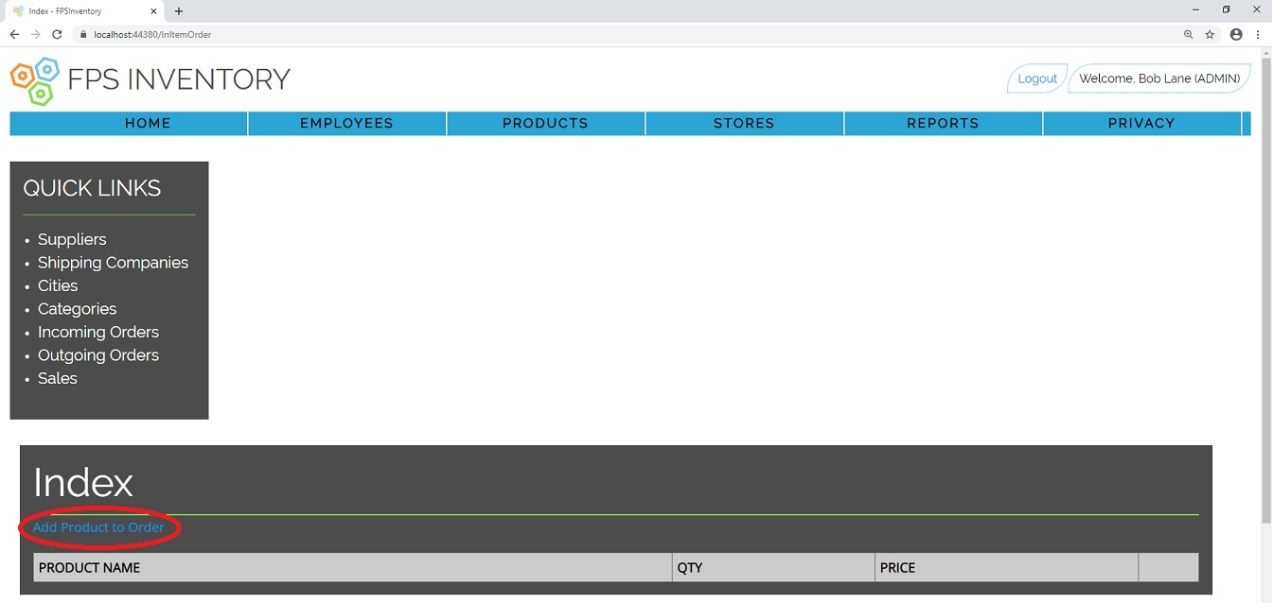

1. Select the product # you wish to order from the dropdown
2. Select the Order # you wish to add the product to.

NOTE: The order you have just created will always appear as the last item in the list.

1. Enter the desired quantity and price of the item.
2. Click “Create” to add item to order

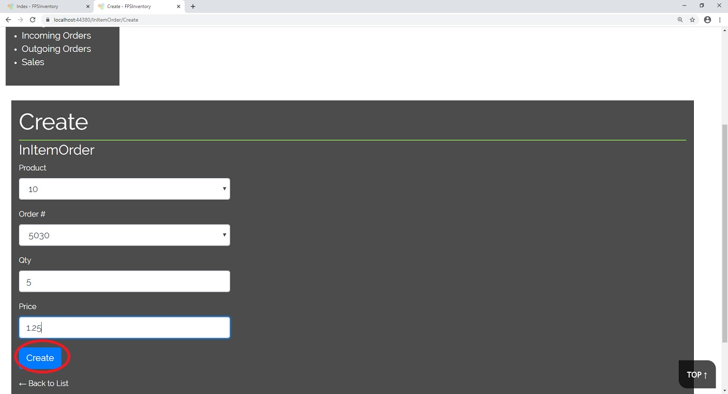

1. Verify item has been added to list.
2. Repeat steps 7-11 as necessary.